1. **Get the department name and total salary, grouped by department name, and sorted by**

**total salary in descending order.**

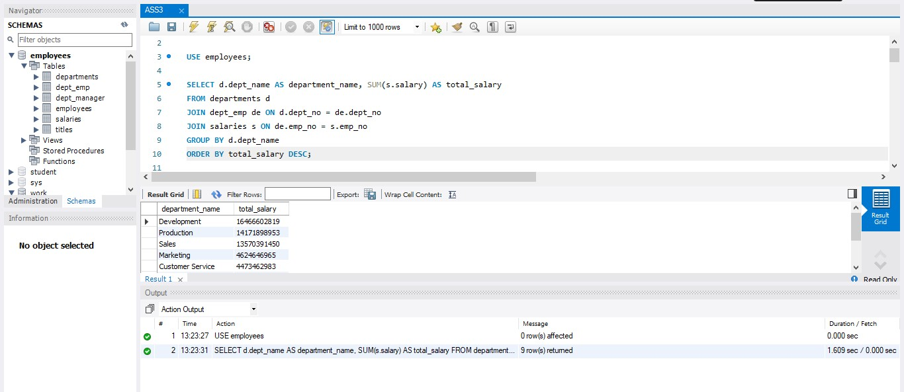

|  |  |
| --- | --- |
| **department name** | **total salary** |
| Development | 16,466,602,819.00 |
| Production | 14,171,898,953.00 |
| Sales | 13,570,391,450.00 |
| Marketing | 4,624,646,965.00 |
| Customer Service | 4,473,462,983.00 |
| Research | 4,080,782,490.00 |
| Finance | 3,924,369,743.00 |
| Quality Management | 3,665,941,336.00 |
| Human Resources | 3,194,340,951.00 |

1. **Get the department name, the number of employees in that department, and the total**

**salary grouped by department name, and sorted by total salary in descending order.**

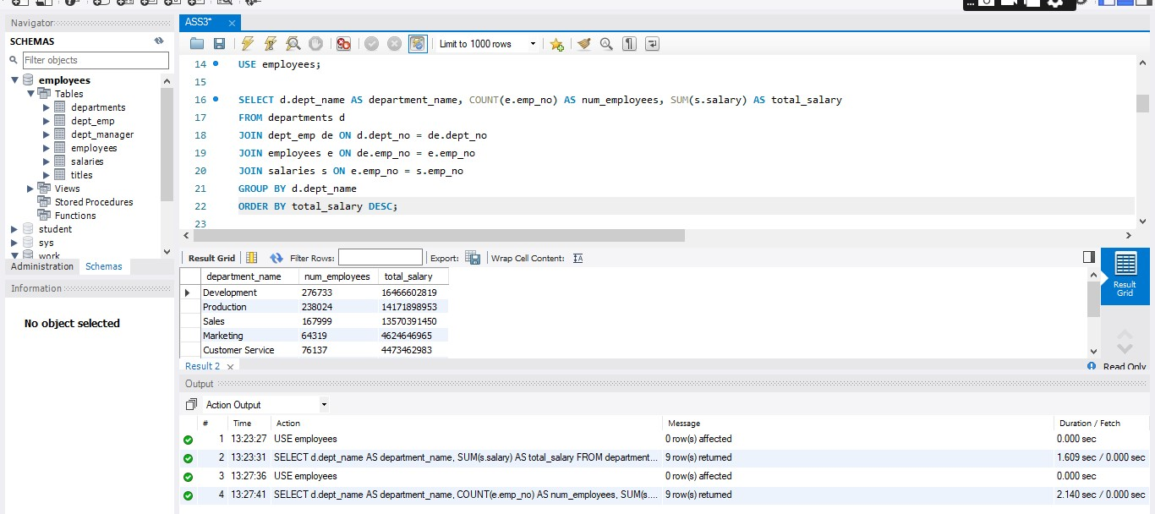

|  |  |  |
| --- | --- | --- |
| **department name** | **Num employees** | **total salary** |
| Development | 276733 | 16,466,602,819.00 |
| Production | 238024 | 14,171,898,953.00 |
| Sales | 167999 | 13,570,391,450.00 |
| Marketing | 64319 | 4,624,646,965.00 |
| Customer Service | 76137 | 4,473,462,983.00 |
| Research | 68165 | 4,080,782,490.00 |
| Finance | 55935 | 3,924,369,743.00 |
| Quality Management | 63984 | 3,665,941,336.00 |
| Human Resources | 57708 | 3,194,340,951.00 |

1. **Get the average salary by employee title in ascending order of salary**

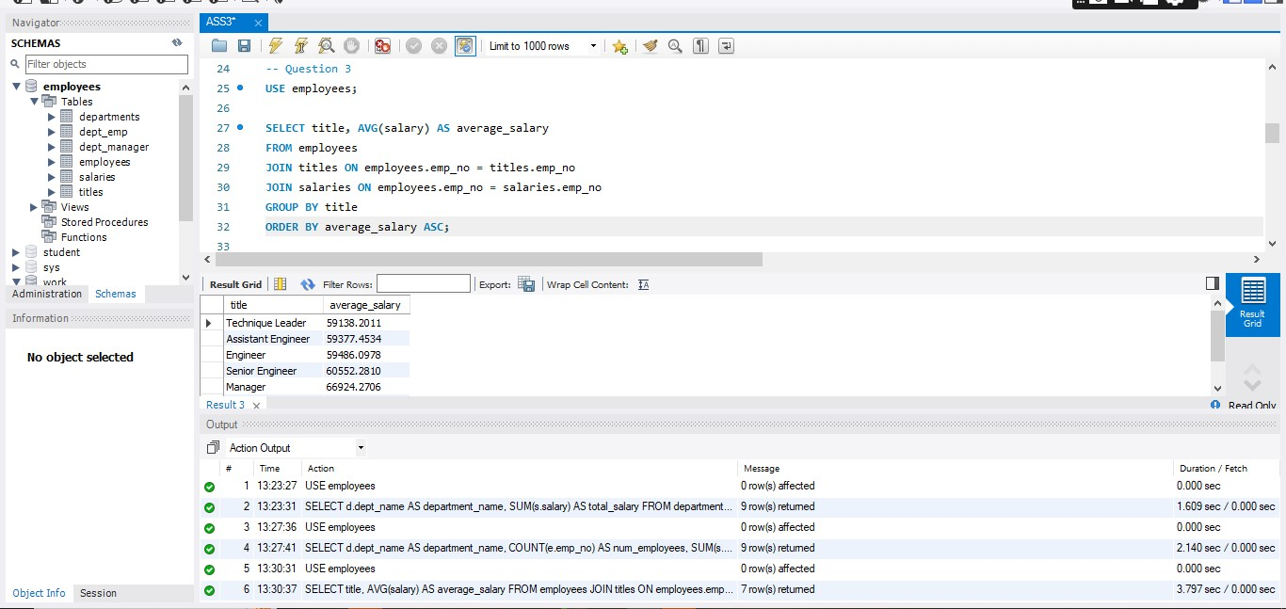

|  |  |
| --- | --- |
| **title** | **average salary** |
| Technique Leader | 59,138.20 |
| Assistant Engineer | 59,377.45 |
| Engineer | 59,486.10 |
| Senior Engineer | 60,552.28 |
| Manager | 66,924.27 |
| Staff | 69,241.76 |
| Senior Staff | 70,398.25 |

1. **Get the maximum salary by department number in ascending order of salary.**

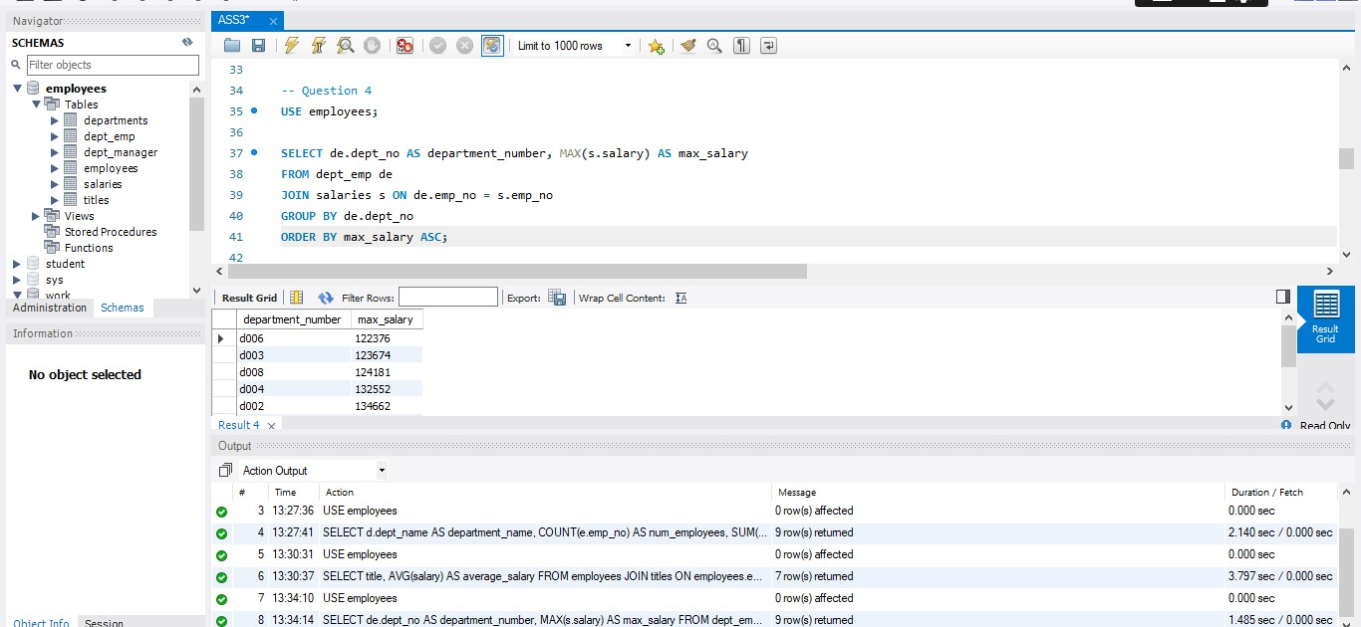

|  |  |
| --- | --- |
| **department number** | **max_salary** |
| d006 | 122,376.00 |
| d003 | 123,674.00 |
| d008 | 124,181.00 |
| d004 | 132,552.00 |
| d002 | 134,662.00 |
| d001 | 143,644.00 |
| d005 | 144,434.00 |
| d009 | 144,866.00 |
| d007 | 158,220.00 |

1. **Get the department name and total salary grouped by the employee number, where the total salary is greater than 10,000, and sorted in descending order of the total salary.**

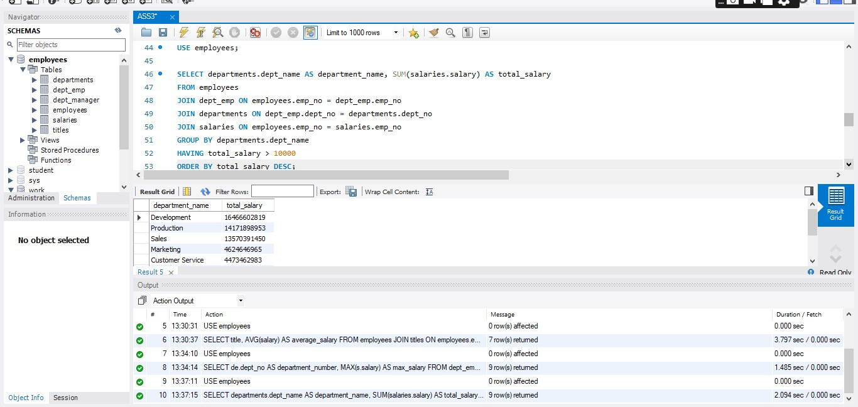

|  |  |
| --- | --- |
| **department name** | **total salary** |
| Development | 16,466,602,819.00 |
| Production | 14,171,898,953.00 |
| Sales | 13,570,391,450.00 |
| Marketing | 4,624,646,965.00 |
| Customer Service | 4,473,462,983.00 |
| Research | 4,080,782,490.00 |
| Finance | 3,924,369,743.00 |
| Quality Management | 3,665,941,336.00 |
| Human Resources | 3,194,340,951.00 |

1. **Extract a dataset containing the following information about the managers: employee number, first name, and last name. Add two columns at the end – one showing thedifference between the maximum and minimum salary of that employee, and anotherone saying whether this salary raise was higher than 30,000 or NOT**

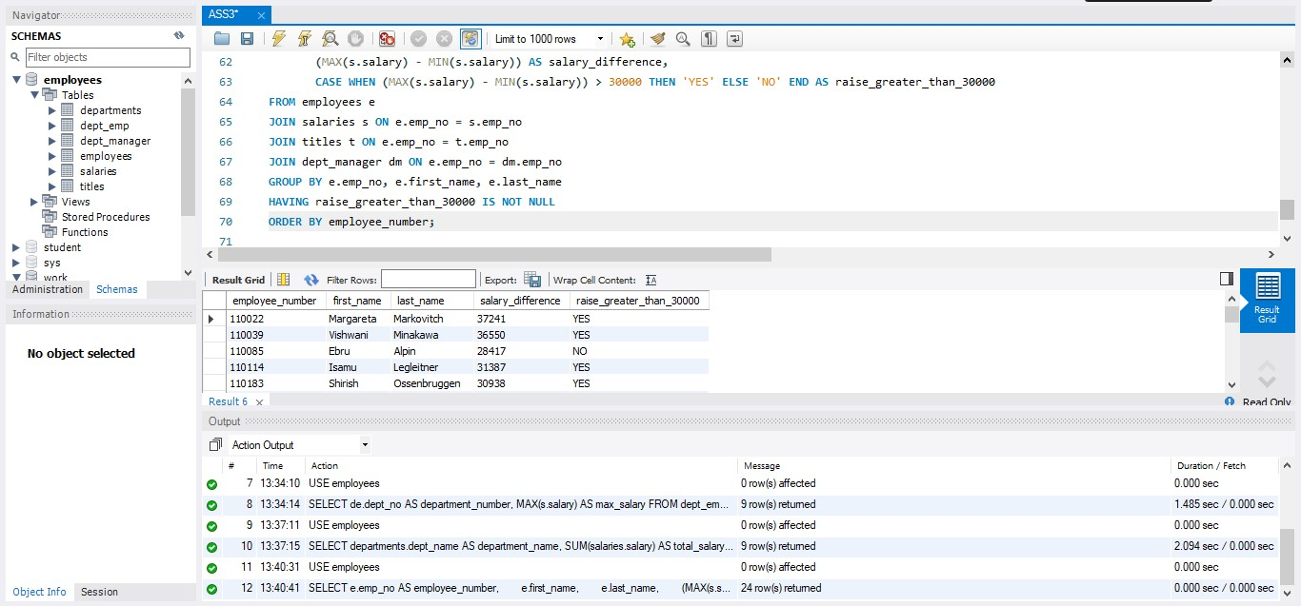

|  |  |  |  |  |  |
| --- | --- | --- | --- | --- | --- |
| employee number | first name | last name | salary difference | raise_greater_than_30000 | |
| 110022 | Margareta | Markovitch | 37241 | YES |  |
| 110039 | Vishwani | Minakawa | 36550 | YES |  |
| 110085 | Ebru | Alpin | 28417 | NO |  |
| 110114 | Isamu | Legleitner | 31387 | YES |  |
| 110183 | Shirish | Ossenbruggen | 30938 | YES |  |
| 110228 | Karsten | Sigstam | 25400 | NO |  |
| 110303 | Krassimir | Wegerle | 30490 | YES |  |
| 110344 | Rosine | Cools | 24756 | NO |  |
| 110386 | Shem | Kieras | 26995 | NO |  |
| 110420 | Oscar | Ghazalie | 16654 | NO |  |
| 110511 | DeForest | Hagimont | 25430 | NO |  |
| 110567 | Leon | DasSarma | 34510 | YES |  |
| 110725 | Peternela | Onuegbe | 31836 | YES |  |
| 110765 | Rutger | Hofmeyr | 32377 | YES |  |
| 110800 | Sanjoy | Quadeer | 27169 | NO |  |
| 110854 | Dung | Pesch | 27707 | NO |  |
| 111035 | Przemyslawa | Kaelbling | 24261 | NO |  |
| 111133 | Hauke | Zhang | 31200 | YES |  |
| 111400 | Arie | Staelin | 30798 | YES |  |
| 111534 | Hilary | Kambil | 31316 | YES |  |
| 111692 | Tonny | Butterworth | 33953 | YES |  |
| 111784 | Marjo | Giarratana | 18189 | NO |  |
| 111877 | Xiaobin | Spinelli | 17560 | NO |  |
| 111939 | Yuchang | Weedman | 18968 | NO |  |